**2024 Higher Level Applied Maths**

**Question 1 (a)**

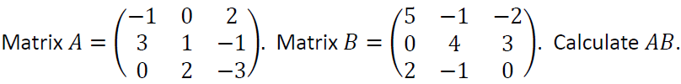

**Question 1 (b)**

A security manager wishes to install cameras in the public areas of a shopping centre.

She wishes to locate these cameras so as to minimise the total length of the cables between them.

In the network shown below node 𝑂 represents the manager’s office. The nodes 𝐴 to 𝐿 represent the locations where the security cameras are to be installed. The weight of each edge represents the distance (in meters) between each location.

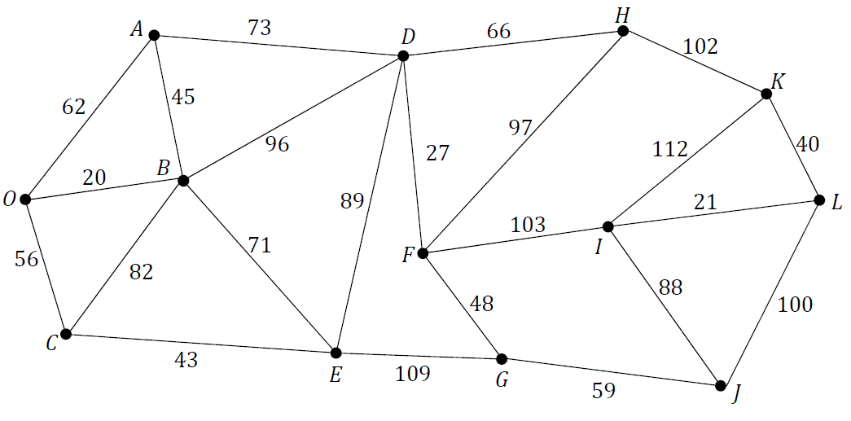

1. Using an appropriate algorithm, find the minimum spanning tree for the network.

Name the algorithm you used. Relevant supporting work must be shown.

1. Calculate the shortest total distance the security manager would have to walk if she started at her office (𝑂) and followed the minimum spanning tree to visit each of the camera locations in the shopping centre.

**Question 1 (c)**

John is cycling on a straight horizontal road at a constant velocity of 10 m s–1 and is 21 m behind another cyclist, Kevin, who is cycling at a constant velocity of 4 m s–1 in the same direction. John begins to accelerate at 2 m s– 2. One second later, Kevin begins to accelerate at 4 m s–2.

Calculate the times when John and Kevin overtake each other.

**Question 2 (a)**

A jeep of mass 2375 kg pulls a trailer of mass 350 kg up a hill inclined at angle 𝜃. The jeep and trailer move at a constant speed. The engine of the jeep exerts a force of 4400 N up the hill. The forces due to friction on the jeep and the trailer are 1525 N and 375 N respectively.

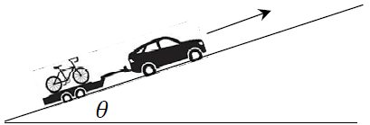**(i)** Draw a diagram to show the forces acting on the jeep.

**(ii)** Calculate 𝜃.

**Question 2 (b)**

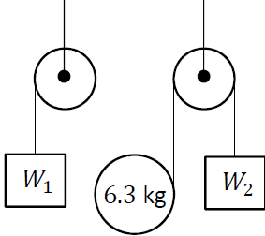A student sets up the pulley arrangement shown in the diagram.

A light inextensible string passes over two smooth fixed pulleys and under a smooth movable pulley of mass 6.3 kg.

Weight 𝑊1 = 24.5 N is attached to one end of the string and weight 𝑊2 = 44.1 N is attached to the other end.

The system is released from rest.

**(i)** Show, on separate diagrams, the forces acting on the pulley and on each of the weights while they are moving.

**(ii)** Calculate the tension in the string.

**Question 3 (a)**

A particle moving along a straight line has acceleration

$a=\frac{dv}{dt}=t^{2}\sin{2t}$ where t ≥ 0, 𝑣 = 0 when 𝑡 = 0.

Using integration by parts or otherwise, calculate 𝑣 when $t=\frac{π}{2}$.

**Question 3 (b)**

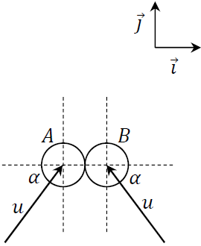Two identical smooth spheres, 𝐴 and 𝐵, each moving with speed 𝑢, collide obliquely. The line joining their centres at the point of impact is along the 𝚤⃗ axis.

Before the collision the velocity of 𝐴 makes an acute angle 𝛼 with the *positive* direction of the 𝚤⃗ axis and the velocity of 𝐵 makes an acute angle 𝛼 with the *negative* direction of the 𝚤⃗ axis, as shown in the diagram.

The coefficient of restitution between the spheres is 𝑒, where 0 ≥ 𝑒 ≥ 1.

1. Calculate, in terms of 𝑒 and 𝑢, the velocity of each sphere after the collision.
2. 𝐴 and 𝐵 move perpendicularly to each other af=er the collision.

Show that 𝑒 = tan 𝛼.

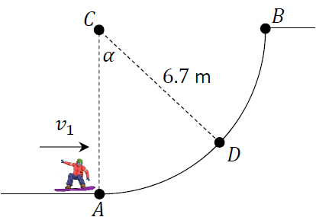**Question 4**

A snowboarder of mass 𝑚 is travelling with velocity 𝑣1 when he enters circular arc 𝐴𝐵 at point 𝐴.

𝐴𝐵 has radius 6.7 m and centre 𝐶.

𝐴, 𝐵 and 𝐶 lie in a vertical plane.

𝐴𝐶 is vertical and 𝐵𝐶 is horizontal.

A student models the motion of the snowboarder, ignoring the effects of friction and air resistance.

1. Draw a diagram to show the forces acting on the snowboarder when he is at point 𝐷, where 𝐶𝐷 makes angle 𝛼 with the downward vertical.
2. Express the reaction force on the snowboarder at point 𝐷 in terms of 𝑚, 𝑣1 and 𝛼.
3. The snowboarder reaches point 𝐵 with vertical velocity 𝑣2.

Express 𝑣2 in terms of 𝑣1.

At point 𝐵 the snowboarder leaves the arc and moves vertically upwards through the air.

The student wishes to calculate 𝑣, the velocity of the snowboarder 𝑡 seconds after he leaves the arc. The force due to air resistance is now modelled as 𝑚𝑘𝑣.

1. Draw a diagram to show the forces acting on the snowboarder while he is moving upwards through the air.
2. Show that while the snowboarder is moving upwards through the air, the rate of change of 𝑣 with respect to 𝑡 can be expressed by the differential equation: $\frac{dv}{dt}= -(g+kv)$
3. Solve this differential equation to find an expression for 𝑣 in terms of 𝑡, 𝑘 and 𝑣1.

**Question 5 (a)**

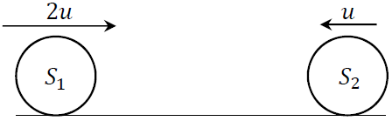Smooth sphere 𝑆1 of mass 2𝑚 and speed 2𝑢 collides directly with smooth sphere 𝑆2 of mass 3𝑚 which is moving in the opposite direction with speed 𝑢.

The coefficient of restitution between the spheres is 𝑒, where 0 ≥ 𝑒 ≥ 1.

1. Calculate, in terms of 𝑒 and 𝑢, the speed of each sphere after the collision.
2. Calculate the range of values for 𝑒 such that after the collision the spheres both move in the same direction.

**Question 5 (b)**

A train departs from Connolly Station and accelerates uniformly from rest for 𝑡1 seconds until it reaches a speed of 𝑣. The train maintains this speed for 𝑡2 seconds, where 𝑡2 = 2𝑡1.

The train then decelerates to rest at Pearse Station in a time of 𝑡3 seconds.

The total time taken for the journey is 𝑇 = 𝑡1 + 𝑡2 + 𝑡3.

1. Show that $T= \frac{2d-t_{2}v}{v}$, where 𝑑 is the distance between Connolly Station and Pearse Station.

**(ii)** If the average speed for the entire journey is $\frac{2v}{3}$, show that 𝑇 = 6𝑡1.

**Question 6 (a)**A statistician is monitoring the population of a small island.

Due to the birth rate being greater than the death rate, the population of the island naturally increases by 1.2% per year. However a fixed number of people, 𝑥, emigrate from the island every year.

The statistician develops a difference equation to model 𝑃n, the population at the beginning of the year 𝑛. The model assumes that emigration occurs at the end of each year.

At the start of the year 2022 there were 13 500 people on the island, i.e. 𝑃0 = 13 500.

1. Write down a difference equation to express 𝑃n+1 in terms of 𝑃n and 𝑥, where 𝑛 ≥ 0, 𝑛 ∈ ℤ.
2. Solve this difference equation to find an expression for 𝑃n in terms of 𝑛 and 𝑥.
3. At the start of the year 2023 there were 13514 people on the island, i.e. 𝑃1 = 13514.

Calculate the value of 𝑥.

1. Calculate the predicted population at the start of the year 2029.

**Question 6 (b)**The acceleration of a particle moving in a straight line may be expressed in terms of its velocity 𝑣 in m s–1 and its displacement 𝑠 in m by the differential equation: $v\frac{dv}{ds}=e^{\frac{v^{2}}{4}}$

**(i)** Solve the differential equation to find an expression for 𝑣 in terms of 𝑠, given that 𝑣 = 0 when 𝑠 = 0.

**(ii)** Calculate the velocity of the particle when 𝑠 = 0.3 m.

**Question 7 (a)**

Fiona plays camogie and wishes to improve her accuracy in scoring points.

She stands at 𝑃, 35 m in front of the goal line and strikes a sliotar with an initial velocity of 20 m s– 1 at an angle 𝛼 to the horizontal ground.

In order to successfully score a point the sliotar must pass over the cross bar which is 2.5 m above the ground, as shown in the diagram.

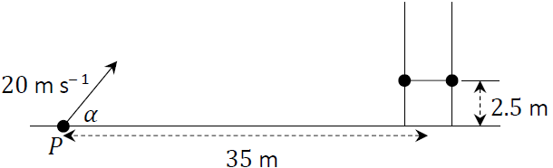

1. Derive an expression, in terms of 𝛼, for the time taken for the sliotar to reach the goal line.
2. Calculate the values of 𝛼 such that the sliotar hits the cross bar.

**Question 7 (b)**

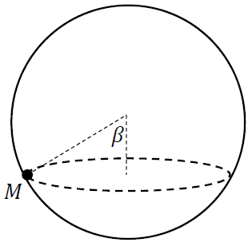In the stunt cage of a circus, a motorcyclist performs acrobatic stunts in a hollow sphere of diameter 20 m.

The motorcyclist and motorbike, labelled 𝑀 in the diagram, have a combined mass of 𝑚 kg.

𝑀 moves with uniform horizontal circular motion.

The line from 𝑀 to the centre of the sphere makes an angle $β=\tan^{-1}{\frac{4}{3}}$ with the downward vertical.

A student models the motion of 𝑀. In the student’s first modelling iteration friction is ignored.

1. Draw a diagram to show the forces acting on 𝑀.
2. Calculate the velocity of 𝑀.
3. The student’s second modelling iteration introduces a coefficient of friction, 𝜇.

Draw a diagram to show the forces acting on 𝑀 when it is on the point of slipping downwards.

1. 𝑀 has velocity 7.5 m s–1 when it is on the point of slipping downwards.

Calculate the value of 𝜇.

**Question 8 (a)**

A company director wishes to design a business plan to promote her brand over four years.

Each year she chooses from a number of different promotion strategies.

She estimates the profit (positive value) or loss (negative value) of each strategy (in €1000’s).

She draws the network shown below to help design the most profitable plan, where the edges represent the different strategies and the nodes represent the possible states associated with the plan at a given point in time.

𝑋 and 𝑌 represent the start point and the end point of the plan respectively.

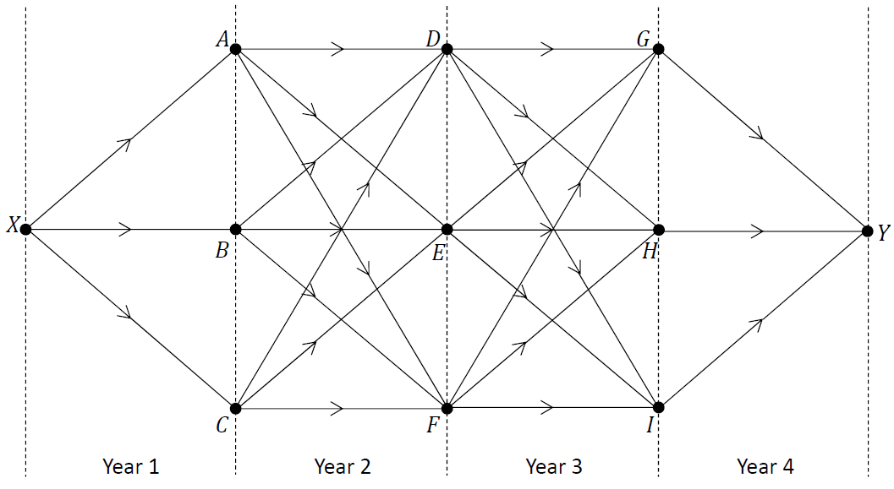

The table below shows the estimated profit (positive value) and the estimated loss (negative value) of each strategy.

|  |  |  |  |
| --- | --- | --- | --- |
| Strategy | Estimated profit/loss | Strategy | Estimated profit/loss |
| *X* to *A* | -11 | *D* to *G* | -5 |
| *X* to *B* | -13 | *D* to *H* | -3 |
| *X* to *C* | -9 | *D* to *I* | 3 |
| *A* to *D* | 5 | *E* to *G* | -2 |
| *A* to *E* | -2 | *E* to *H* | 5 |
| *A* to *F* | -5 | *E* to *I* | 6 |
| *B* to *D* | 7 | *F* to *G* | 4 |
| *B* to *E* | -3 | *F* to *H* | 3 |
| *B* to *F* | 4 | *F* to *I* | 2 |
| *C* to *D* | 5 | *G* to *Y* | 6 |
| *C* to *E* | -4 | *H* to *Y* | 5 |
| *C* to *F* | -1 | *I* to *Y* | 7 |

1. Use Bellman’s Principle of Optimality to calculate the business plan that maximises profit.

Relevant supporting work must be shown.

1. State one difference between Bellman’s Principle of Optimality and Dijkstra’s algorithm.

**Question 8 (b)**

The algebraic formula below is written in terms of force 𝐹, mass 𝑚, displacement 𝑠 and angular velocity 𝜔.

$$\sqrt{\frac{4Fs}{mω^{2}}}$$

Use dimensional analysis to show that this formula has the same units as the units for displacement.

**Question 9**

A geologist is carrying out a survey of an opal mine.

During the first month of mining, a mass of 200 kg of opal was removed. During the second month of mining, a mass of 245 kg of opal was removed.

The geologist predicts that 𝑀, the mass of opal removed in any month, can be expressed by the second‐order homogeneous difference equation:

$$M_{n+2}=M_{n+1}+\frac{3M_{n}}{4}$$

where 𝑛 ≥ 0, 𝑛 ∈ ℤ, 𝑀0 = 200 and 𝑀1= 245.

1. Write down the values of 𝑀2 and 𝑀3.
2. Solve the difference equation to find an expression for 𝑀n in terms of 𝑛.
3. Calculate the total mass of opal that is predicted to be removed during the first six months of mining.

After the government introduces stricter mining laws, the geologist changes their predictions by estimating that the mass of opal mined in month 𝑛 will be reduced by 2n kg.

The geologist predicts that 𝑃, the mass of opal removed in any month, can now be expressed by the second‐order inhomogeneous difference equation:

$$P_{n+2}=P_{n+1}+\frac{3P_{n}}{4}-2^{n+2}$$

where 𝑛 ≥ 0, 𝑛 ∈ ℤ, 𝑃0 = 199 and 𝑃1 = 243.

1. Solve this new difference equation to find an expression for 𝑃􀯡 in terms of 𝑛.
2. Calculate the total mass of opal that is now predicted to be removed during the first six months of mining.

**Question 10 (a)**

The diagram below shows the scheduling network for manufacturing a car.

The edges of the network represent the activities that have to be completed as part of the overall manufacture of the car and are labelled with the letters 𝐴 to 𝐿. The duration, in weeks, of each activity is represented by the number in brackets. The unlabelled edges (shown with dashed lines) do not represent real activities but they help explain the order in which the activities must happen. The letters used to label the edges should **not** be taken as representing the order in which the activities happen.

The nodes of the network represent events or points in time during the project. The source node is the time when the project begins and the sink node is the time when the project ends.

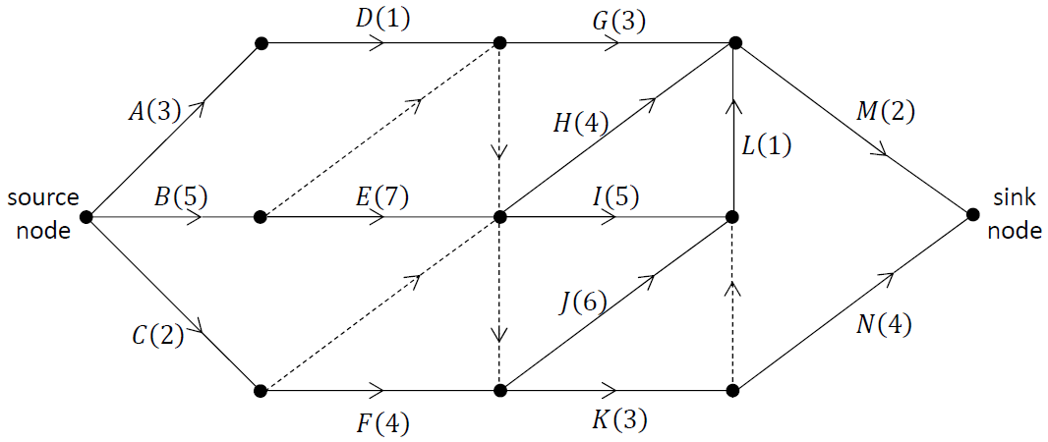

1. Calculate the early time and the late time for each event.

Complete the diagram below by writing the early time (upper box) and late time (lower box) at the node representing each event.

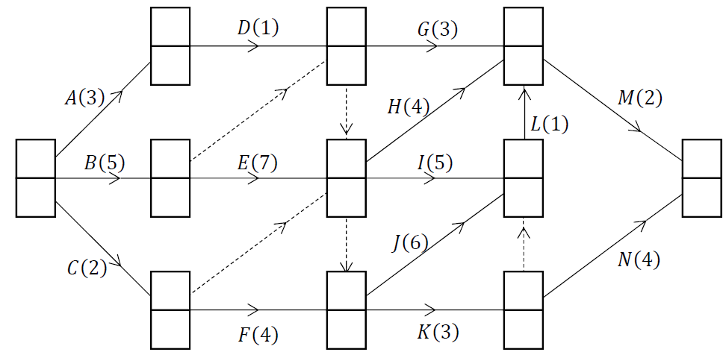

1. Write down the critical path(s) for the network.
2. What is a critical path?
3. If activity 𝐾 takes 5 weeks instead of 3 weeks, what effect will this have on the critical path(s) and the time it takes to complete the project?   
   Explain your answer.

**Question 10 (b)**

A tank of uniform cross‐sectional area contains water of height 𝑥 m.

Water leaves the tank through a pipe at its base.

The rate at which the height of the water decreases is proportional to 𝑥.

At time 𝑡 = 0, 𝑥 = 𝐻. At 𝑡 = 45 s, $x=\frac{H}{3}$.

Calculate 𝑡 when $x=\frac{H}{8}$.